YEAR 12 PHYSICS

SEMESTER TWO EXAMINATION 2004

Name: _________________________

Teacher: _______________________

TIME ALLOWED FOR THIS PAPER

Reading time before commencing work: Ten minutes
Working time for paper: Three hours

MATERIAL REQUIRED/RECOMMENDED FOR THIS PAPER

TO BE PROVIDED BY THE SUPERVISOR

This Question/Answer Booklet
Physics Formulae and Constants Sheet
Sheet of standard graph paper

TO BE PROVIDED BY THE CANDIDATE

Standard Items: Pens, pencil, eraser, correction fluid and ruler

Special Items: Drawing instruments, templates and calculators satisfying the conditions set by the Curriculum Council.

IMPORTANT NOTE TO CANDIDATES

No other items may be taken into the examination room.

It is your responsibility to ensure that you do not have any unauthorised notes or other items of a non-personal nature in the examination room. If you have any unauthorised material with you hand it to the supervisor BEFORE reading any further.

STRUCTURE OF PAPER

Section | No. of questions | No. of questions to be attempted | No. of marks out of 200 | Proportion of examination total
A: Short Answers | 15 | ALL | 60 | 30%
B: Problem Solving | 6 | ALL | 100 | 50%
C: Comprehension and Interpretation | 2 | ALL | 40 | 20%

INSTRUCTIONS TO CANDIDATES

Write your answers in the spaces provided beneath each question. The value of each question (out of 200) is shown following each question.

The Physics Data Sheet must also be submitted with your exam.

Calculators satisfying the conditions set by the Curriculum Council may be used to evaluate numerical answers.

Answers to questions involving calculations should be evaluated and given in decimal form. Quote the final answer to no more than three significant figures. Despite an incorrect final result, credit may be obtained for method and working, provided these are clearly and legibly set out.

Questions containing specific instructions to show working should be answered with a complete, logical, clear sequence of reasoning showing how the final answer was arrived at; correct answers which do not show full working will not be awarded full marks.

Questions containing the instruction estimate may give insufficient numerical data for their solution. Students should provide appropriate figures to enable an approximate solution to be obtained.

SECTION A: Short Answers

Marks Allotted: 60 marks out of total of 200 marks (30%)

Attempt ALL 15 questions in this section. Each question is worth 4 marks. Answers are to be written in the space below or next to each question.

  - With the aid of an energy level diagram, explain the phenomenon of fluorescence.
  - Give an example from a context that you have studied, how the phenomenon of fluorescence can be put to use.
- The diagram shows a sumo wrestler in a typical wrestling stance. Explain why a sumo wrestler is so stable.
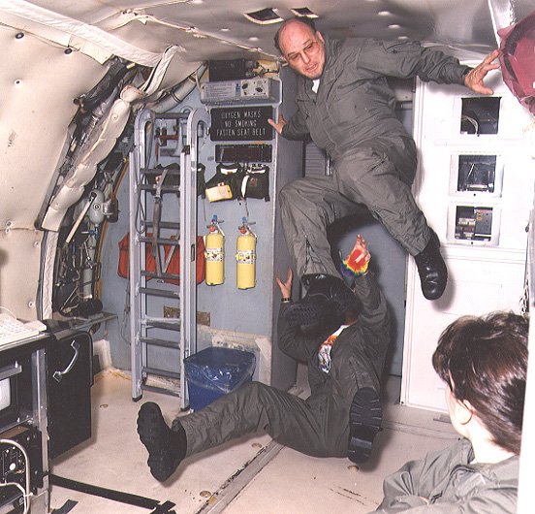
- The picture shows some NASA personnel experiencing an artificial “gravity-free” environment. It is achieved by allowing a large 747 jetliner to go into periods of “free-fall” during its flight (the plane is nicknamed the vomit comet!). Explain why the occupants experience weightlessness.

- A Physics teacher recorded the sound level in a classroom when 15 students are talking at a normal volume, he finds the reading is 76.0 dB. Assuming that all students are the same distance form the sound meter and they all speak with the same volume, find the reading if only 2 students were speaking.
- The diagram below shows a ring of wire of radius 2.00 cm, which is immersed in a uniform magnetic field of intensity 50.0 mT. The ring is pulled to the left and is clear of the magnetic field in 0.15 s.

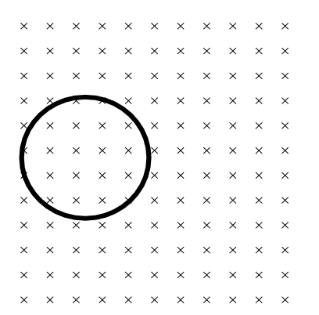
  - Indicate on the ring the direction of any induced current.
  - If the ring has a resistance of 0.03 Ω, find the average current induced.
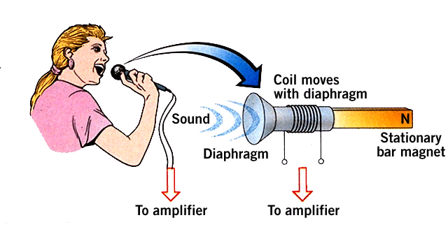
- The diagram shows the inner working of a simple microphone. Briefly explain how such a device can convert “sound” energy to “electrical” energy.
- A microwave oven is being used to heat a potato. If the microwave oven delivers 600.0 W of power to the potato, estimate the number of photons of hitting the potato each second. (hint: use your data sheet to help estimate the frequency and/or wavelength of microwaves)

- The diagram below shows a bus part-way along a bridge that is supported by two pillars. The 22.0 m bridge is uniform and has a mass of 32.0 tonne. The bus has a mass of 12.5 tonne and its centre of mass is 8.50 m from the left end of the bridge. Find the force exerted by each pillar.
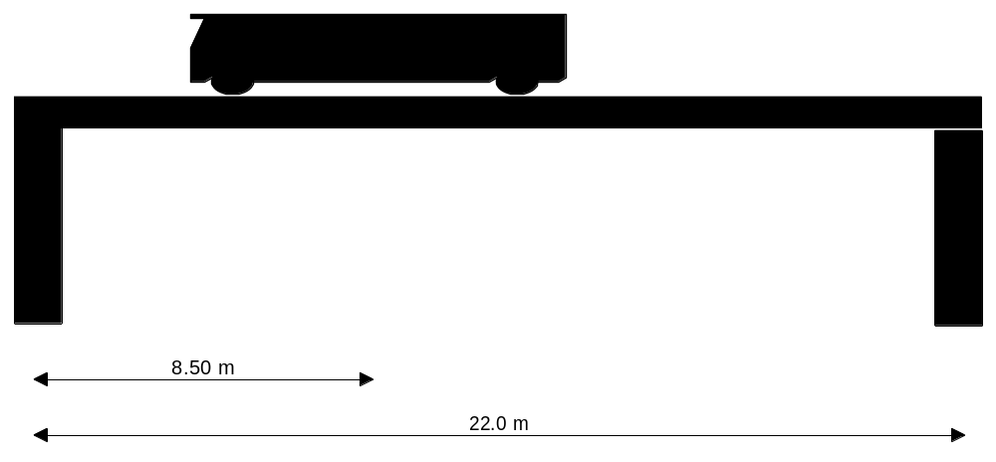
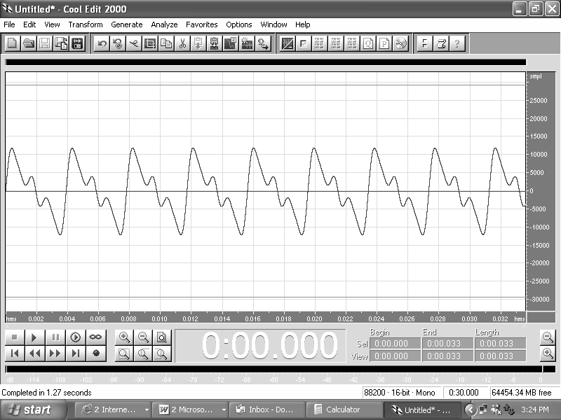
- The diagram below shows how the sound level varied with time when a note was played on a particular musical instrument.
TIME AXIS
  - Is the note a “fundamental note” or are there other harmonics present? Explain.

  - Given that the time axis units are seconds. Estimate the frequency of the note.
- The diagram shows Wei Ho rounding a circular bend on his bicycle.
  - Show with an arrow, the net force on Wei Ho as he rounds the bend.
  - Explain why Wei Ho must lean his bicycle has he takes the corner.
- An electron is fired directly into a uniform magnetic field of intensity 230 μT with a velocity of 2.6 x 10⁵ m s⁻¹.
  - Indicate on the diagram the path that the electron will follow.
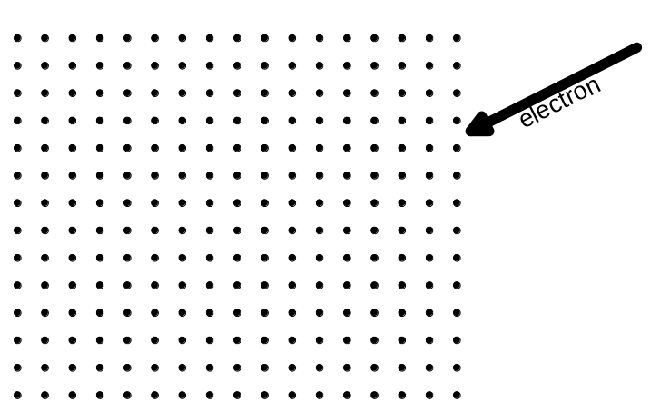
  - Find the radius of curvature of the electron’s path in the magnetic field.

- The diagram shows an ingenious device that assists people opening jars of food when the lid is difficult to remove. Explain the Physics behind the device.
DOWNLIGHTS
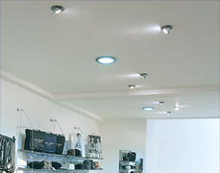
- Modern downlights are low voltage devices that are supplied with their own transformer. Typically, downlights operate on 12 V AC. Even if a room has four downlights installed, each is equipped with its own 240 V to12 V transformer.
Explain why several downlights in a house would not be connected to the same transformer.
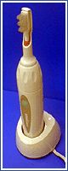
- Electric toothbrushes recharge when they are placed back in their holder. Modern electric toothbrushes have no “metal contacts” between the brush and the holder. Suggest how the battery in the brush could be recharged without metal contacts completing a circuit.

- The simple graphs below could be used to describe a variety of situations. For the situations given, suggest a suitable graph.
Note: Not all graphs need to be used, and some may be used more than once.
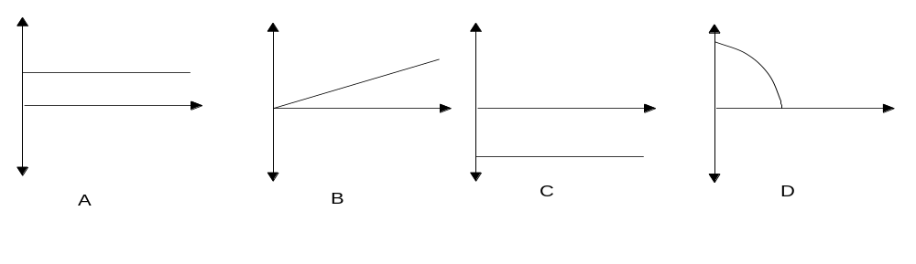
  - The horizontal component of the velocity of a projectile, such as an arrow (ignoring air resistance), plotted against time.
____
  - The magnitude of the net acceleration, of a small mass, being spun in a vertical circle at the end of a length of string with a constant speed, plotted against time.
____
  - The vertical acceleration of a projectile, such as an arrow (ignoring air resistance)., plotted against time.
____
  - The intensity of the sound produced by noisy machine, plotted against distance.
____
This page has been left blank intentionally.
SECTION B: Problem Solving

Marks Allotted: 100 marks out of total of 200 marks (50%)

This section contains 6 questions. You should answer ALL of the questions and show full working.

Answer all questions in the spaces provided.

- [19 marks]
  - Draw a diagram to show the magnetic field surrounding each of the following:
    - Two solenoids (coils) a short distance apart.
[2 marks]
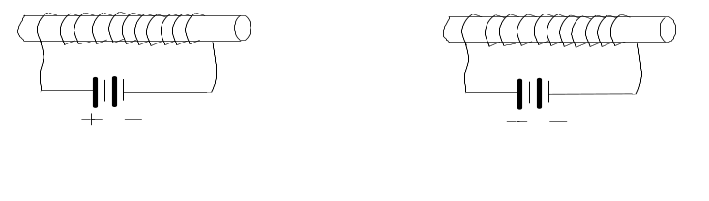
    - Two current carrying wires, one carrying current into the page and one carrying current out of the page. You do NOT need to show how the magnetic fields of the two wires would interact.
[2 marks]

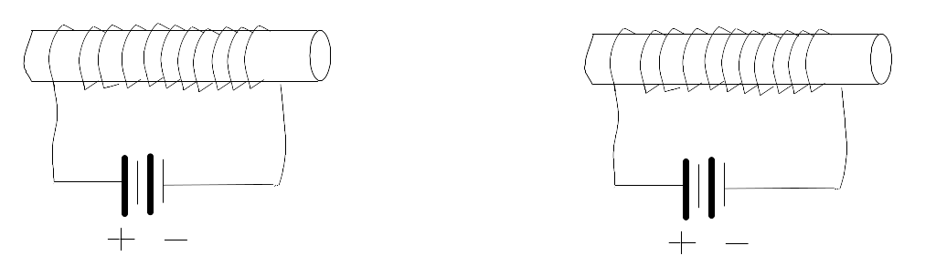

    - Now draw a diagram of the magnetic when the wires from part (b) are placed between the coils of part (a). Use the completed diagram to briefly explain the electric motor principle.
[4 marks]
  - A typical DC electric motor is shown below.
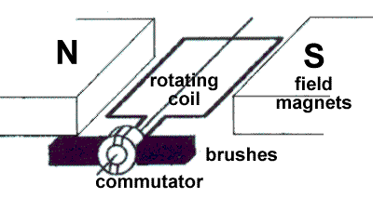
    - Explain the purpose of the commutator and brushes.
[2 marks]
    - In what ways would an actual electric motor differ from the one shown in the diagram?
[2 marks]
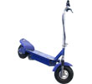
    - Would the position shown in the above diagram, be one for maximum or minimum torque? Explain.
[2 marks]
  - A commercial electric motor used in electric scooters uses 350 Watts of power at its maximum power output, while providing a torque of 0.78 Nm. If the voltage supplied is 36.0 V, find:
    - The current drawn by the motor.
[1 mark]
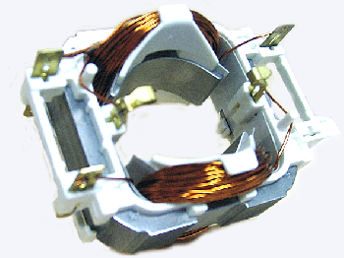
    - Given that 70% of this current is used in the armature (rotating coil) of the motor and the coil’s dimensions are 10.0 cm by 10.0 cm and consists of 250 turns, find the magnetic field intensity provided by the stator windings (the stator windings provide the stationary magnetic field in a motor). [4 marks]
Stator windings
The stator of an electric motor.


- [13 marks]
Hamish is attempting a clever trick. His toy car is traveling at 6.0 m s⁻¹ on a small ramp inclined to the horizontal which he placed on top of a table. Under the table on the floor, his toy truck is traveling at 3.5 m s⁻¹. At the position shown, the car is directly above the back of the truck. Hamish is trying to get the toy car to land in the back of the toy truck. The top of the ramp is 58 cm above the back of the truck.
  - At what angle should the ramp be inclined to the horizontal for the trick to be achieved?
[3 marks]
  - How far beyond the edge of the table do the toys travel, before the car lands in the truck? (ie: what horizontal distance is covered by the toys once the car leaves the ramp?)
[5 marks]
  - Calculate the speed and direction of the car when it lands in the back of the truck.
[5 marks]

- [18 marks]
The diagram below shows a 2 500 kg car which is attached to the end of a 115 kg uniform rod which is pivoted on the wall of a building. A cable of length 3.4 m and diameter
22 mm, supports the rod and the car. The rod makes a 50º angle with the wall and a 60º angle with the cable.
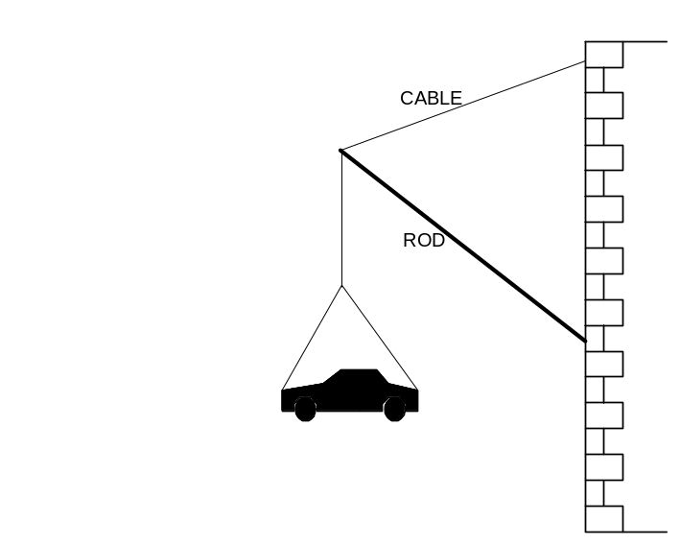
  - On the diagram above, show all of the forces acting on the rod. Use a red pen for this if you have one.
[4 marks]
50º
60º
  - Find the tension in the cable.
[4 marks]
  - Find the force of compression in the rod.
[4 marks]

  - Given that the cable is made from mild steel, determine the amount by which the cable has stretched when loaded in this way.
[4 marks]
  - If a shorter, but horizontal rod had been used instead, how would this have affected your answer to part (d)? Explain. NOTE: Do not have to re-calculate the answer.
[2 marks]
- [19 marks]
Modern values for the mass of the Earth and other planets have been determined by observing the motion of artificial satellites that have been launched in recent years.
  - Derive an expression for the mass of a central body, for example the Earth, in terms of the orbital radius (r) and orbital period (T) of an artificial satellite.
[3 marks]
  - One of Mars’ moons, Phobos revolves around Mars with an orbital radius of
9.35 x 10³ km and with a period of 7 hours and 35 minutes. Use your expression from part (a) to determine the mass of Mars.
[3 marks]
  - What is the value for the acceleration due to gravity ‘g’ on the surface of Mars,
given that Mars has a radius of 3 430 km?
[2 marks]
  - What is the orbital speed of Phobos (in m s⁻¹)?
[2 marks]
  - Is Phobos accelerating? Explain.
[2 marks]

  - One Mars day is equivalent to 1.024 Earth days. What altitude must a Martian geostationary satellite have? (note: a geostationary satellite, or geosynchronous satellite is one that remains above the same geographical location)
[4 marks]
  - A space shuttle flies at 250 km h⁻¹ as it reaches the top of a vertical loop of radius
512 m, near the surface of Mars. What is the 75 kg pilot’s apparent weight at the top of this loop? (ie: what force is the pilot’s seat exerting on the pilot?)
[3 marks]
512 m
- [15 marks]
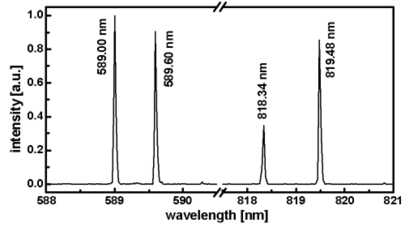
  - One of the most well-known emission spectra is that of sodium. One feature of this spectrum is two very close spectral lines. The wavelengths of these lines are 589.0 nm and 589.6 nm.
Wavelength (m)
    - Explain the origin of these lines.
[2 marks]
    - Determine the spacing (in eV) of the two energy levels involved.
[3 marks]
  - A beam of 3.5 eV electrons is fired at a sodium vapor sample. The kinetic energy of the emitted electrons is measured and found to be 3.5 eV, 1.4 eV and 0.30 eV.
    - Why do the energies of the emitted electrons vary?
[2 marks]
    - Sketch a representation of some of the energy levels of a sodium atom based on the information given.
[3 marks]
    - Determine the energy and wavelength of the highest energy photon that would be emitted from the sample of sodium vapour based on the given data.
[2 marks]
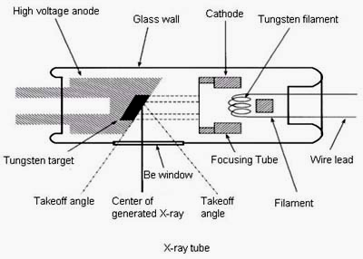
  - Use the diagram below to briefly describe how x-rays are produced.
[3 marks]
- [16 marks]
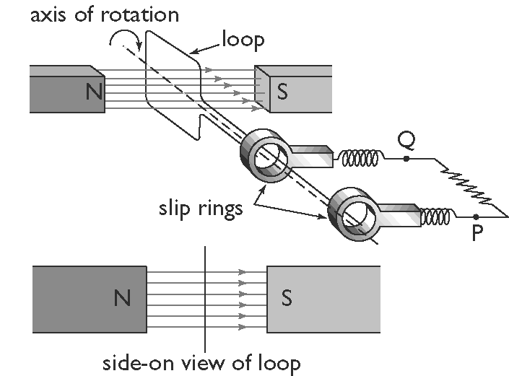
  - The diagram below shows a simple AC electric generator.
As the loop is rotated in the magnetic field, an emf is induced. The graph below shows how the induced emf varies with time.
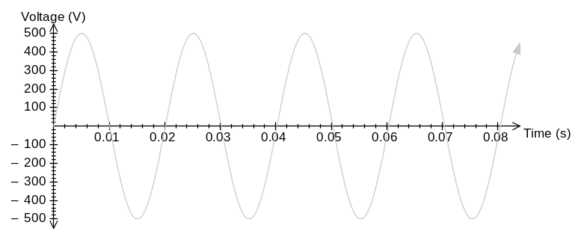
A
B
    - Which point, A or B, could possibly correspond to the point of rotation shown in the diagram?
[1 mark]
    - With what speed, in revolutions per second, is the generator turning?
[1 mark]
    - In a typical single phase AC generator, the average emf induced is 350 V and its rotating coil consists of 500 turns. Find the magnetic flux (Φ) in the generator.
[4 marks]
    - In a commercial power station, the generators have electromagnets to provide the magnetic field. What are some of the advantages and disadvantages of this design principle? [4 marks]
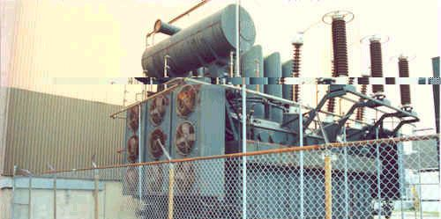
  - At Pinjar power station, the electricity is produced at 350 V and then stepped up to 132 000 V before it is transmitted to the city.
COOLING SYSTEM
A Western Power
Step-up Transformer
    - The transformer has an extensive cooling system to remove the large quantities of heat produced in the transformer. Why does the transformer produce this heat?
[2 marks]
    - The energy lost as heat, reduces the theoretical output voltage by 10 000 V. What would the turns ratio of the transformer need to be, for the output voltage to be the desired 132 000 V?
[2 marks]
    - Why is it necessary to step up the voltage before it is transmitted?
[2 marks]
SECTION C: Comprehension and Interpretation [40 Marks]

BOTH questions should be attempted.
Read the following passages and answer the questions at the end of each. Candidates are reminded of the need for clear and concise presentation of answers. Diagrams (sketches), equations and/or numerical results should be included as appropriate. Note: These articles use the imperial measuring system, for your information: 1 foot = 30 cm, 1 inch = 2.5 cm.

- AUDITORIUM ACOUSTICS – Reflections Make All the Difference
By Arthur Noxon
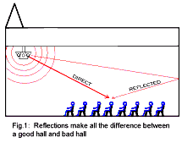
Some reflections are good, others not so good
There are three types of reflections that people hear in an auditorium: Early reflections, late reflections and reverberation. Early reflections are good, late reflections are generally bad and reverberation varies between good to bad. The "voice of the hall" depends on the nature of the sequence of reflections heard by the people in the audience.
Echoes can be fun but they also ruin the understanding of speech
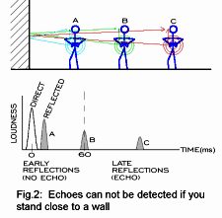
Early reflections are those that bounce off nearby objects. But when the object is located some distance away, the situation changes, you can hear the reflection off of it and we call this acoustic event an "echo". An echo can be great fun at times but when it's time to pay attention to someone talking, it also makes listening very difficult. The echo is a good example of a "late reflection" because it is a reflection that can be distinguished as being separate from the direct signal.
Late reflections ruin listening to speech
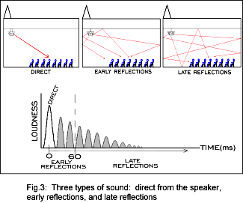
Late reflections are those reflections that are
distinguishable as separate acoustic events from
the direct signal. Echoes are late reflections. Multiple reflections, strings of echoes are late reflections. There can be just a few late reflections or many late reflections. Late reflections are those that arrive after about 60 ms following the reception of the direct signal. They can stretch out up to around 250 ms (1/4 seconds) or so. If you concentrate you might be able to identify where some of them come from. When too many are coming, there is no hope to separate them out in terms of direction or timing but you still hear them as being separate from the sound of the direct signal. (Figure-3).
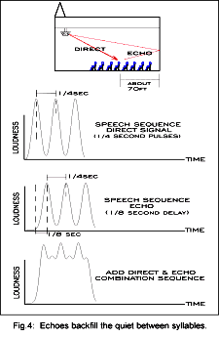
In order to understand speech, it is important to hear the start, the sound and the ending of each syllable. Each syllable contains both loudness and tonal variations that add emphasis and can even meaning to the ultimate word. To understand speech, we must be able to hear and understand the rapid changing sonic variations within the syllables of speech. When people are speaking, they produce about 4 complete sonic events per second and frequently interspersed with short quiet moments. We can imagine a model for speaking that generates a sequence of sounds each lasting 1/8th second followed by 1/8th second silence.
Anything that backfills the 1/8th second quiet times between syllables is noise and tends to mask or block out the understanding of the signal. (Figure-4). Late reflections easily backfill those quiet 1/8th second periods, causing separated speech syllables to seem to slur together. The excessive presence of late reflections makes the difference between a room that yodels and a room that gargles.
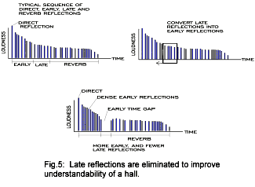
Late reflections are best converted into early reflections when ever possible because this helps with the understanding of the direct sound. There are two other ways to get rid of late reflections (including echoes): Absorption or diffusion. If late reflections are absorbed, they are removed from the sonic space entirely and the overall loudness of the subsequent reverberation is markedly reduced. If late reflections are diffused, scattered about, they are not removed from the sonic space and the reverberation remains loud.
Reverberation
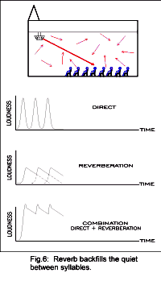
This type of sound is no longer made up of a distinct set of reflections. Reverberation is a different kind of sound, it feels different, seems to roll. It comes from everywhere and nowhere all at the same time. It is fairly quiet and creates the feeling of largeness. It is the kind of sound that begins to be felt starting about 1/4 second after the direct signal passes by and lasts out some 2 to more 5 seconds. It is the rounds of sound in the room that slowly dies out and it is the very last thing we hear of a sound before the hall finally falls silent. (Figure-6).
Reverberation is a general din of noise that takes a long time to die out compared to the rapid sequences of speech sounds. Two people are close together and talking in a bare gym. They understand each other. Then they start backing away from each other and keep talking. At some point, maybe about 30 feet apart, they can no longer really understand each other. The loudness of the reverberation is the same anywhere in the room. The rate of reverb dying out in the room remains the same everywhere in the room. What happens as the talkers separate is that the direct sound becomes weaker because of the increased distance until it is finally too weak compared to the reverb noise level and understanding is lost.
Early Reflections help with listening
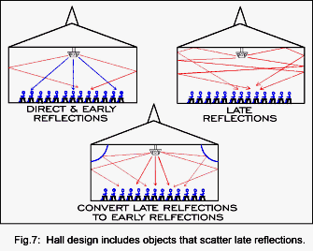
Of all the types of reflections only one, early reflections, actually add to the direct signal to create a louder, more clearly understood sound. Early reflections have to arrive at the listener within the first 60 ms following the direct signal. The distance from the loudspeaker to the surface providing an early reflection and then back down to the listener can not be more than 50 feet longer than the direct distance between the loudspeaker and the listener.
Sound spreads out from the loudspeaker and some of it might miss the congregational seating area and hit the sidewall. If the sidewall is close enough to a group of listeners that the reflection washing over them off the sidewall arrives within 50 ms of the direct signal, this wall reflection aids in hearing what is being said. It is easier to hear an early reflection coming in from an area in front of us, above us or to the side of us than if the reflection comes in from behind us due to the way our ears are shaped.
Ceilings and sidewalls can be shaped or they can be fitted with objects that create early reflections landing in the seating area. Balcony facings, and balcony ceilings can provide substantial early reflections. Pillars (especially big, hollow fake ones) can be placed in special locations along the sidewalls to cause early reflections. They are also good for catching upper rear wall reflections and side scattering them. Softly rounded soffits (an external area under the overhang of a roof) placed high on the sidewalls provide a second set of early reflections. The open space above the soffits can be used for uplighting. (Figure-7).
Another form of early reflections is often seen in auditoriums and music halls, it is the suspended acoustical cloud. These flying wings seem to loom overhead and to some greatly compromise the visual integrity of a "traditional" space. The problem is however that the traditional space doesn't acoustically work very well. At any rate, suspended acoustic clouds are positioned and shaped to intercept upward bound sound and rescatter it back down into the audience area, all within the early reflection time period.
Finally, early reflections can be faked (simulated) by adding a distributed sound system. These speakers are played at a fairly low sound level, about 5 dB below the strength of the direct signal and each speaker is on a specific time delay so that the "early reflection" arrives within 50 ms after the direct signal. Line source or customized planar loudspeakers are best for this application. The more common two-way box speaker is much more apt to be spotted by the listening ear. The line or planar speakers project sound more evenly over greater distances, they essentially feel more like a reflection.

  - Why is an echo defined as a late reflection? (page 24)
[2 marks]

  - What is the main acoustic problem caused by late reflections? (page 25)
[2 marks]

  - How can late reflections be eliminated in an auditorium? (page 25)
[3 marks]

  - Explain how an echo differs from reverberation (page 25)
[4 marks]

  - Why are early reflections more desirable than late reflections? (page 26)
[3 marks]

  - Explain how auditoriums are designed to maximise early reflections. (page 26)
[ 6 marks]

THE IMPACT OF ADVANCED MATERIALS IN OLYMPIC SPORT
By F. H. Froes.

Pole Vault
The 1896 Olympics saw a height of ten feet, six inches achieved with a bamboo pole in the pole-vault event. In the 1960s, after the pole-vault record had inched upwards for 60 years, records began to fall as aluminium poles were introduced. Today, the world class pole vaulter utilizes a highly sophisticated composite pole, resulting in a 1996 record of 19 feet, five inches.
Table I. Typical Mechanical Properties of Materials Classes
Material | Young's Modulus  (E) (MPa) | Density  (p)(Mg/m⁻³) | E/p
Metal | 40,000-210,000 | ~2-8 | 24,000-30,000
Glass | 73,000 | ~2.5 | ~30,000
Ceramic | 400,000-700,000 | ~3.5 | 100,000-230,000
Fibres (B, C) | ~400,000 | ~2.4 | ~170,000
Carbon-Fibre Composite | 200,000 | 2.0 | 100,000
Wood | 14,000 | 0.5 | 28,000
The materials requirements for a vaulting pole and the corresponding materials of choice are shown in Table II. It can easily be shown that the specific design property is given by
Table II. Material Requirements for a Vaulting Pole
Requirement | Possible Material
Light (Low Density) | Bamboo
Buckling Resistance(Stiffness) | Aluminium
Strong (Resistance to Plastic Strain) | Steel
Minimal Twisting (High Torsional-Strain Resistance) | Magnesium
Cost | Carbon Fibre Composite
, where E is Young’s Modulus and ρ is density

If we refer to Table I and also add the requirement of durability, the material of choice is the carbon-fibre composite, with bamboo not too far behind. If we add the minimal-twisting requirement, the carbon-fibre composite becomes even more attractive (Figure 1), with three layers of different fibres being used to optimize the performance, an outer layer of high-strength carbon fibre providing high stiffness and an intermediate webbing of fibres together with an inner layer of wound-glass fibre building resistance to twisting. The glass fibre consists of 80% longitudinal and 20% radial fibres.
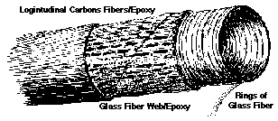
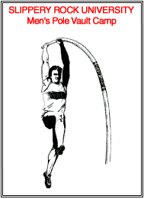
Figure 1: The vaulting pole, showing the three layers of different fibres used to maximize stiffness while minimizing twisting during use.
Figure 2: An athlete pole vaulting.

Bicycling
Cycling is a highly efficient form of transportation, with energy consumption lower than that of a walker and much lower than that of powered vehicles. The Chinese recognize this, building more than 10 million bicycles per year. The bicycle has been around for almost 200 years, maturing from the 1817 Draisienne (walking device) to the modern day Rover safety bicycle designed by J.K. Starley in 1885.
Today, advanced materials, in combination with aerodynamic consideration, have led to vastly improved bicycles. Greg LeMond won the 1989 Tour de France (3,420 km) by only 8 seconds, a success made possible by a clip-on extension of his handlebars and a padded tube that enhanced his aerodynamic shape.

Figure 3. The bicycle diamond frame.
A number of advances have contributed to the high efficiency of the modern-day bicycle, including the development of spoked wheels, the chain concept, pneumatic tires, and accessories (e.g., seats, brake levers, and pedals). However, the two major advances are in the frame and wheels.
The bicycle can be considered as a modified spaceframe such as that found in bridges, cranes, etc.; the bicycle has a diamond frame (Figure 3). The diamond frame and the alternate-structure cross frame are constructed from thin-walled tubular components that must resist tension, compression, bending, and torsional stresses when in use. The requirements and possible materials of choice are shown in Table III.
These materials requirements can be simplified to the minimization of the bending of a cantilever beam, then the mass is given by
M = Constant x E /
Thus, the optimum material is the one with the highest specific strength, E/. Based upon the data shown in Table I, carbon-fibre composites are the materials of choice if there is no concern over cost. Aluminium, magnesium, and titanium are also attractive. If cost is a concern, then steel (which is not that far behind the other materials) is the obvious material for selection.
In addition to the carbon-fibre-reinforced composite frames, frames have recently been produced from magnesium, aluminium, titanium, and metal-matrix composites. In addition, hybrid frames such as carbon-fibre-reinforced composites combined with titanium have been produced.
Table III. The Materials Requirements for a Bicycle
Requirement | Possible Material
Light (Low Density) | Carbon-Fibre Composites
Stiffness | Aluminium
Strength | Titanium
Toughness | Magnesium
Fatigue | Resistance Steel
Corrosion Resistance | Metal-Matrix Composites
Wheels with increased stability and rigidity for off-road bikes constructed from glass-fibre-reinforced nylon and disc wheels have been constructed. In disc wheels, discs made of aluminium alloys or carbon-fibre-reinforced composites replace the spokes in conventional wheels. Developments also include three- or five-spoked wheels for rigidity and cross-wind aerodynamics.
The improvements that advanced materials have produced in bicycling can be gauged in the enhancement in the Olympic pursuit records. In 1964, Daler won the 4,000 meters individual pursuit with a time of five minutes, five seconds; in 1992, Boardman won the event in three minutes, 22 seconds.

  - According to Table I (page 29), the best material for a vaulting pole is ceramic. Why then, is a carbon-fibre composite used?
[4 marks]

  - The outer layer of composite vaulting pole plays a different role to the inner most layer. Describe the construction of each layer and the reasoning behind the composite design. (page 29)
[4 marks]

  - What type of stresses are bicycle frames subjected to? (page 30)
[2 marks]

  - Figure 3 is repeated here. Assuming that the frame is under a normal load, indicate with a ‘T’, a part of the frame in tension, with a ‘C’, a part of the frame in compression and with a ‘B’ a part of the frame that must resist bending.
[3 marks]
  - The article suggests that steel is a very good material for building bike frames. Why do you think steel is not used extensively in modern bicycle frames?
[3 marks]

  - Cycling records and pole vaulting records continue to be broken. What reasons for this are cited in the article?
[2 marks]



  - Bicycle tyres have a curved profile (contact point with the road), while car tyres have a flat profile. Use your knowledge of Physics to briefly explain why this is so?
[2 marks]
ACKNOWLEDGEMENTS
END OF PAPER

SECTION C

Question 1: Adapted from: “Auditorium Acoustics 102”, By Arthur Noxon.
Reflections Make All the Difference. Downloaded from http://www.church- acoustics.com/aa102.pdf June 2004.

Question 2: Adapted from: “Is the Use of Advanced Materials in Sports Equipment Unethical?” by F.H. Froes, University of Idaho, School of Mines. Downloaded from http://www.tms.org/pubs/journals/JOM/9702/Froes-9702.html#ToC3 June 2004.

